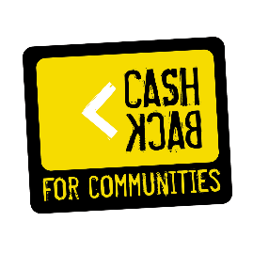

Youth Work Lead Person Specification

Personal Qualities

Essential

- Enthusiastic, non-judgemental attitude towards children & young people.
- Understanding of, and belief in, empowerment and the positive abilities of children & young people.
- An awareness of and commitment to equal opportunities and anti-discriminatory practice.
- Understanding of issues facing young people within society.
- Commitment to redress inequalities, value opinions, and empower individuals to take action on issues affecting their lives.
- Initial belief and understanding of promoting the personal and social development of children & young people.
- A willingness and desire to learn.
- Understanding and commitment to treat each young person as a unique individual.

Experience

Essential

- Minimum of 2 years paid youth work experience.
- Relevant professional qualification
- Skills, knowledge or experience relevant to the youth work agenda.
- Experience in planning, delivering and evaluating needs led youth work programmes involving young people in the process.
- Delivery of youth work program
- Delivery of youth work awards or SQA qualifications

Desirable

- One to one working.
- Understanding of youth mental health issues
- Understanding of trauma-informed practice

Skills & Abilities

Essential

- Ability to work in a team and use own initiative.
- Excellent interpersonal skills
- Ability to contact, engage and motivate young people.
- Ability to plan by setting targets, meeting objectives and effectively monitor and evaluate performance.
- Ability to creatively engage young people.
- Ability to diffuse hostile situations between young people.
- Hold UK Driving Licence – Car owner

Desirable

- IT skills.
- Understanding of and commitment to the voluntary sector.
- Excellent networking skills
- Confidence to deliver presentations.

